

|  |
| --- |
| **Mobile Programming**  **LAB3** |
|  |



|  |
| --- |
| **제출일 2014, 04, 25 전공 소프트웨어학과** |
| **과목 모바일 프로그래밍 이름 유수화** |

Lab 3.1

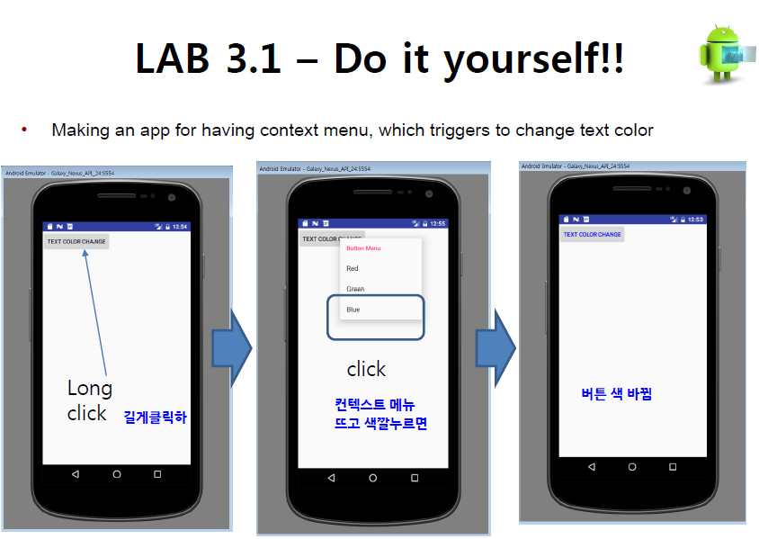

activity_main.xml

<?xml version="1.0" encoding="utf-8"?>  
<LinearLayout  
 xmlns:android="http://schemas.android.com/apk/res/android"  
 android:layout_width="match_parent"  
 android:layout_height="match_parent"  
 android:orientation="vertical">  
  
 <!-- When you click this button, a context menu opens. -->  
 <Button  
 android:id="@+id/button"  
 android:layout_width="wrap_content"  
 android:layout_height="wrap_content"  
 android:text="Text Color Change" />  
  
</LinearLayout>

menu_main.xml

<?xml version="1.0" encoding="utf-8"?>  
<menu xmlns:android="http://schemas.android.com/apk/res/android">  
 <!-- Create Contextual menu -->  
 <item  
 android:id="@+id/red"  
 android:title="Red"/>  
 <item  
 android:id="@+id/green"  
 android:title="Green"/>  
 <item  
 android:id="@+id/blue"  
 android:title="Blue"/>  
</menu>

MainActivity.java

package example.com.lab3_1;  
  
import android.graphics.Color;  
import android.os.Bundle;  
import android.support.v7.app.AppCompatActivity;  
import android.view.ContextMenu;  
import android.view.MenuItem;  
import android.view.View;  
import android.widget.Button;  
  
public class MainActivity extends AppCompatActivity {  
  
 Button mBtn;  
 @Override  
 protected void onCreate(Bundle savedInstanceState) {  
 super.onCreate(savedInstanceState);  
 setContentView(R.layout.*activity_main*);  
  
 // When you click this button, a context menu opens.  
 mBtn = (Button) findViewById(R.id.*button*);  
 //Register the view to which the context menu should be associated.  
 registerForContextMenu(mBtn);  
 }  
  
 //When the register view receives a long-click event,  
 //this method is called by system.  
 public void onCreateContextMenu(ContextMenu menu, View v, ContextMenu.ContextMenuInfo menuInfo)  
 {  
 super.onCreateContextMenu(menu, v, menuInfo);  
 menu.setHeaderTitle("Button Menu");  
  
 //To add a menu item to the context menu,  
 // you create an instance of the MenuItem class and use the add() method of the Menu object.  
 // Four arguments : groupId, itemId, order, title  
 menu.add(0, 1, 0, "Red");  
 menu.add(0, 2, 0, "Green");  
 menu.add(0, 3, 0, "Blue");  
  
 }  
  
 // When the user selects a menu item, this method is called by system.  
 public boolean onContextItemSelected (MenuItem item){  
 int itemId = item.getItemId();  
 if (itemId == 1) {mBtn.setTextColor(Color.*RED*); return true;}  
 if (itemId == 2) {mBtn.setTextColor(Color.*GREEN*); return true;}  
 if (itemId == 3) {mBtn.setTextColor(Color.*BLUE*); return true;}  
 return true;  
 }  
  
}

Screen-shot

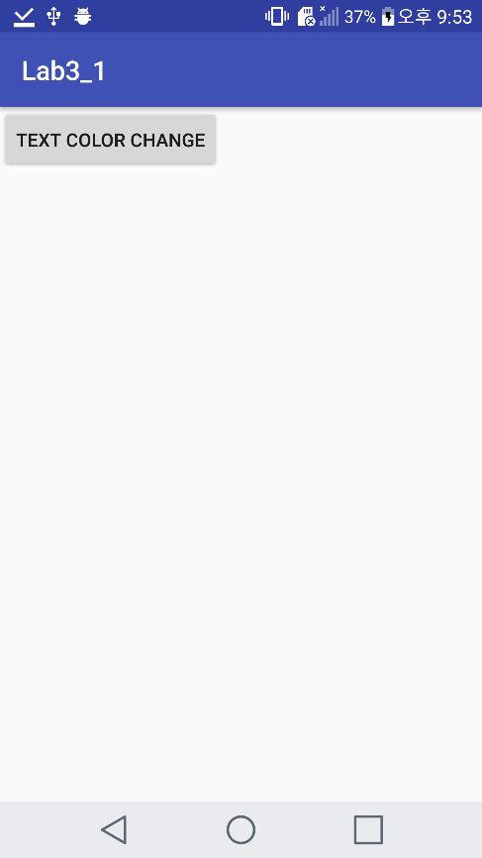 Initial screen

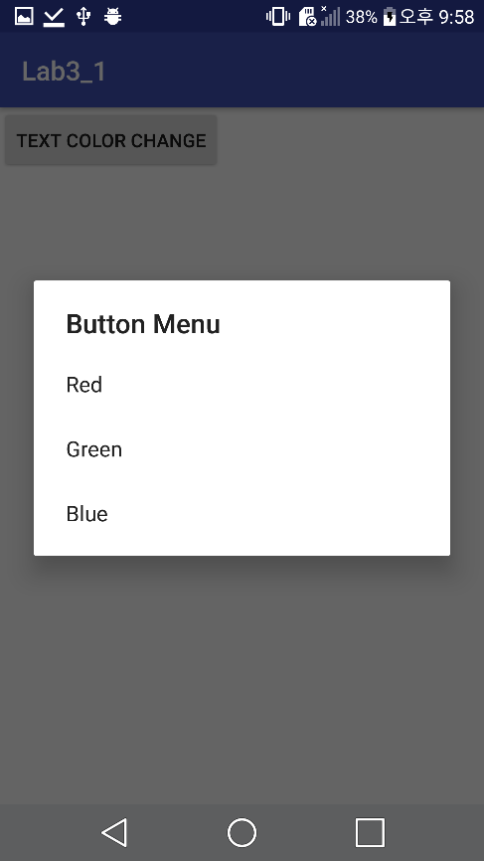 Long Press for Context menu

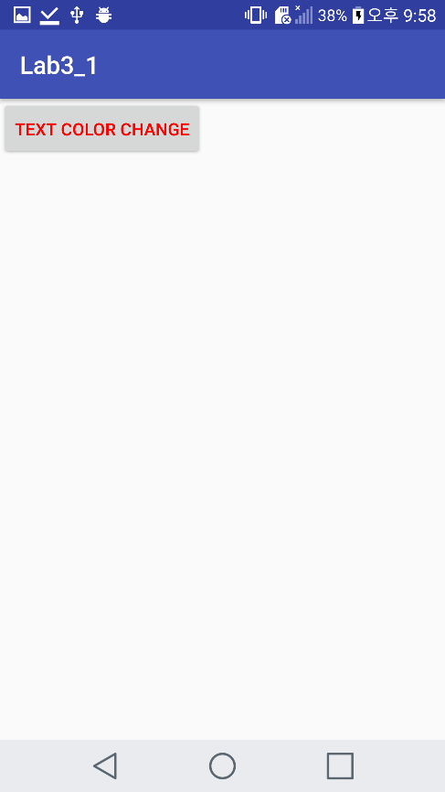 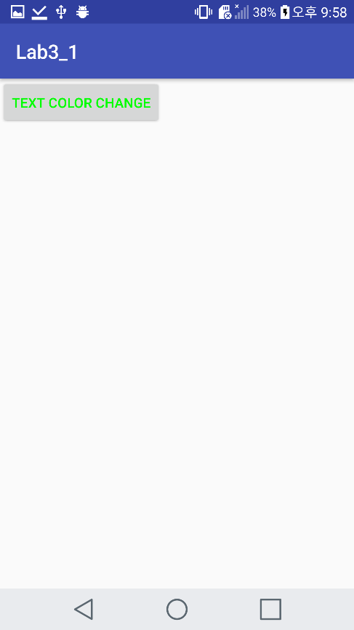

Color Red Color Green

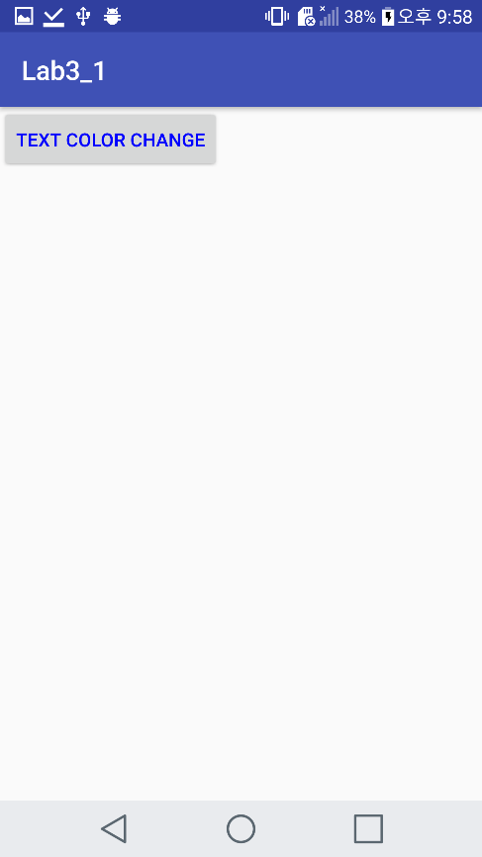

Color Blue

Lab3.2

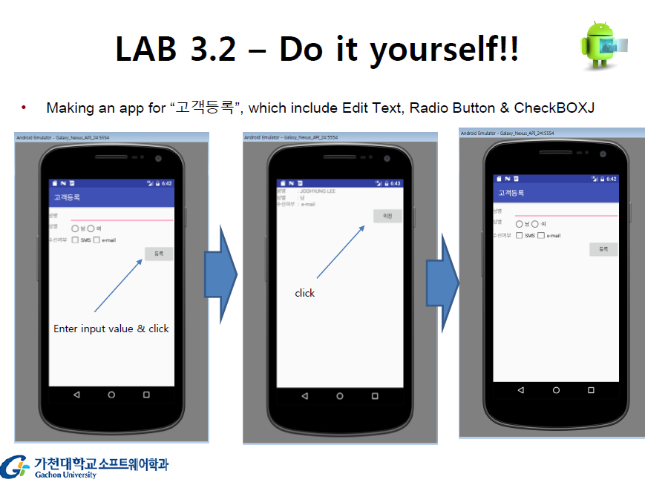

activity_main.xml

<?xml version="1.0" encoding="utf-8"?>  
<TableLayout xmlns:android="http://schemas.android.com/apk/res/android"  
 android:layout_width="match_parent"  
 android:layout_height="match_parent"  
 android:stretchColumns="1">  
  
 <!-- This table row include textView and editText -->  
 <TableRow>  
 <TextView android:text="성명" />  
 <EditText  
 android:id="@+id/name"  
 android:layout_span="2" />  
 </TableRow>  
  
 <!-- This table row include textView and RadioButton -->  
 <TableRow>  
 <TextView android:text="성별" />  
 <RadioGroup  
 android:id="@+id/radioGroup"  
 android:orientation="horizontal">  
 <RadioButton  
 android:id="@+id/male"  
 android:layout_width="wrap_content"  
 android:layout_height="wrap_content"  
 android:text="남" />  
  
 <RadioButton  
 android:id="@+id/female"  
 android:layout_width="wrap_content"  
 android:layout_height="wrap_content"  
 android:layout_marginLeft="6dp"  
 android:text="여" />  
 </RadioGroup>  
 </TableRow>  
  
 <!-- This table row include textView and CheckBox -->  
 <TableRow>  
 <TextView  
 android:text="수신여부" />  
  
 <!-- Layout that contains CheckBoxes To set the horizontally. -->  
 <LinearLayout  
 android:orientation="horizontal">  
 <CheckBox  
 android:id="@+id/SMS"  
 android:layout_width="wrap_content"  
 android:layout_height="wrap_content"  
 android:text="SMS" />  
  
 <CheckBox  
 android:id="@+id/eMail"  
 android:layout_marginLeft="6dp"  
 android:layout_width="wrap_content"  
 android:layout_height="wrap_content"  
 android:text="email" />  
 </LinearLayout>  
  
 </TableRow>  
  
 <TableRow>  
 <!-- When you click this button, a new activity opens. -->  
 <!-- Use layout_gravity(right) To place the button on the right side of the parent's view. -->  
 <Button  
 android:id="@+id/btnEnter"  
 android:layout_column="1"  
 android:layout_gravity="right"  
 android:text="등록" />  
 </TableRow>  
  
</TableLayout>

MainActivity.java

package example.com.lab3_2;  
  
import android.content.Intent;  
import android.os.Bundle;  
import android.support.v7.app.AppCompatActivity;  
import android.text.TextUtils;  
import android.view.View;  
import android.widget.Button;  
import android.widget.CheckBox;  
import android.widget.EditText;  
import android.widget.RadioButton;  
import android.widget.Toast;  
  
public class MainActivity extends AppCompatActivity implements View.OnClickListener {  
 RadioButton male, female;  
 CheckBox SMS, eMail;  
 EditText editName;  
  
 //onCreate() : Called when the activity is first created.  
 @Override  
 protected void onCreate(Bundle savedInstanceState) {  
 super.onCreate(savedInstanceState);  
 setContentView(R.layout.*activity_main*);  
  
 editName = (EditText) findViewById(R.id.*name*);  
 male = (RadioButton) findViewById(R.id.*male*);  
 female = (RadioButton) findViewById(R.id.*female*);  
 SMS = (CheckBox) findViewById(R.id.*SMS*);  
 eMail = (CheckBox) findViewById(R.id.*eMail*);  
  
 Button btnCommit = (Button) findViewById(R.id.*btnEnter*);  
 btnCommit.setOnClickListener(this);  
 }  
  
 // Check whether information has been entered.  
 // If you don't enter the information, show toast to enter the information.  
 public boolean isEmpty() {  
  
 if (TextUtils.*isEmpty*(editName.getText().toString())) {  
 Toast.*makeText*(this, "이름을 입력하세요", Toast.*LENGTH_SHORT*).show();  
 return false;  
 }  
 if ((!male.isChecked()) && (!female.isChecked())) {  
 Toast.*makeText*(this, "성별을 선택하세요", Toast.*LENGTH_SHORT*).show();  
 return false;  
 }  
 return true;  
 }  
  
 //When you click this button, a new activity(page) opens.  
 //Send name and sex, check reception through the intent.  
 @Override  
 public void onClick(View v) {  
  
 if( isEmpty())  
 {  
 Intent intent = new Intent(this, example.com.lab3_2.NewActivity.class);  
 StringBuffer buffer = new StringBuffer();  
  
 if (male.isChecked()) {  
 intent.putExtra("sex", ":"+male.getText().toString());  
 } else if (female.isChecked()) {  
 intent.putExtra("sex", ":"+female.getText().toString());  
 }  
 intent.putExtra("name", ":"+editName.getText().toString());  
  
 buffer.append(":");  
 if (SMS.isChecked())  
 buffer.append("SMS");  
 if (eMail.isChecked()) {  
 if (buffer.length() == 0)  
 buffer.append("e-mail");  
 else  
 buffer.append(" & e-mail");  
 }  
  
 if (buffer.length() == 0)  
 buffer.append("none");  
  
 intent.putExtra("check", buffer.toString());  
  
 startActivity(intent);  
 finish();  
 }  
  
 }  
}

activity_new.xml

<?xml version="1.0" encoding="utf-8"?>  
<TableLayout xmlns:android="http://schemas.android.com/apk/res/android"  
 android:layout_width="match_parent"  
 android:layout_height="match_parent"  
 android:stretchColumns="1">  
  
 <!-- This table row include two textViews. -->  
 <!-- One of these text views shows the NAME information received from previous activity(MainActivity). -->  
 <TableRow>  
 <TextView android:text="성명" />  
 <TextView  
 android:id="@+id/Fname"  
 android:layout_marginLeft="6dp"  
 android:layout_span="2" />  
 </TableRow>  
  
 <!-- This table row include two textViews. -->  
 <!-- One of these text views shows the SEX information received from previous activity(MainActivity). -->  
 <TableRow>  
 <TextView android:text="성별" />  
 <TextView  
 android:id="@+id/Fsex"  
 android:layout_marginLeft="6dp"  
 android:layout_span="2" />  
 </TableRow>  
  
 <!-- This table row include two textViews. -->  
 <!-- One of these text views shows the CHECK RECEPTION information received from previous activity(MainActivity). -->  
 <TableRow>  
 <TextView  
 android:text="수신여부" />  
 <TextView  
 android:id="@+id/Fcheck"  
 android:layout_marginLeft="6dp"  
 android:layout_span="2" />  
 </TableRow>  
  
 <TableRow>  
 <!-- When you click this button, go back to the previous activity(MainActivity). -->  
 <!-- Use "layout_gravity(right)" To place the button on the right side of the parent's view. -->  
 <Button  
 android:id="@+id/btnBack"  
 android:layout_column="1"  
 android:layout_gravity="right"  
 android:text="이전" />  
 </TableRow>  
</TableLayout>

NewActivity.java

package example.com.lab3_2;  
  
import android.content.Intent;  
import android.os.Bundle;  
import android.support.v7.app.AppCompatActivity;  
import android.view.View;  
import android.widget.Button;  
import android.widget.TextView;  
  
public class NewActivity extends AppCompatActivity implements View.OnClickListener {  
  
 //onCreate() : Called when the activity is first created.  
 @Override  
 public void onCreate(Bundle savedInstanceState) {  
 super.onCreate(savedInstanceState);  
 setContentView(R.layout.*activity_new*);  
  
 Intent intent = getIntent();  
  
 TextView txtName = (TextView)findViewById(R.id.*Fname*);  
 TextView txtSex = (TextView)findViewById(R.id.*Fsex*);  
 TextView txtCheck = (TextView)findViewById(R.id.*Fcheck*);  
  
 //Receive information from previous activity through intent.  
 //And then set Text of TextViews that from intent.  
 txtName.setText(intent.getStringExtra("name"));  
 txtSex.setText(intent.getStringExtra("sex"));  
 txtCheck.setText(intent.getStringExtra("check"));  
  
 Button btnBack = (Button)findViewById(R.id.*btnBack*);  
 btnBack.setOnClickListener(this);  
 }  
  
  
 //When you click this button(btnBack),  
 // this activity(NewActivity.java) is finished  
 // and the go back to the previous activity(page).  
 @Override  
 public void onClick(View v) {  
 switch(v.getId()) {  
 case R.id.*btnBack*:  
 startActivity(new Intent(this, MainActivity.class));  
 finish();  
 break;  
 }  
 }  
}

Screen-shot

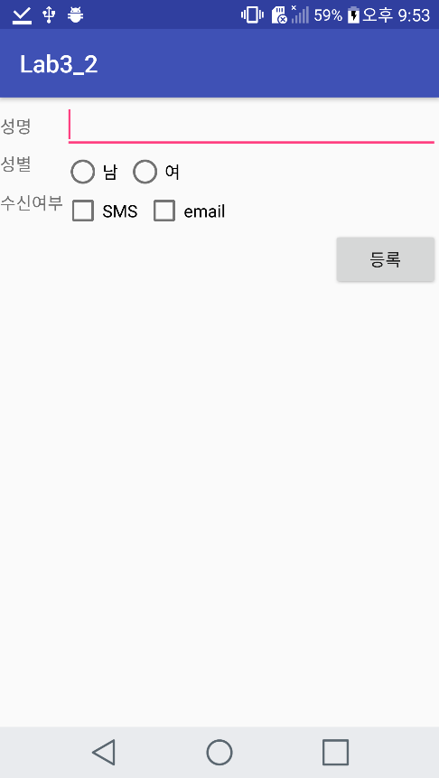 Initial screen (Main activity)

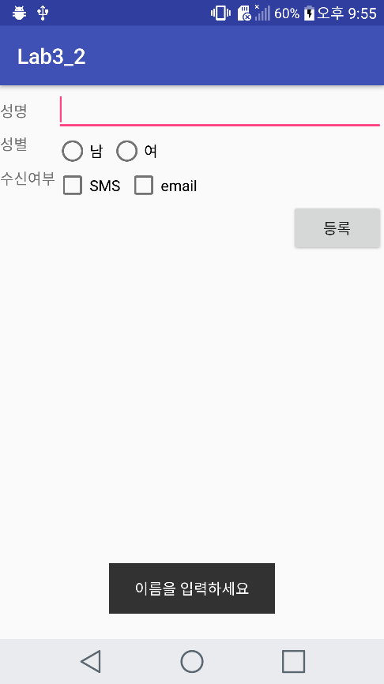 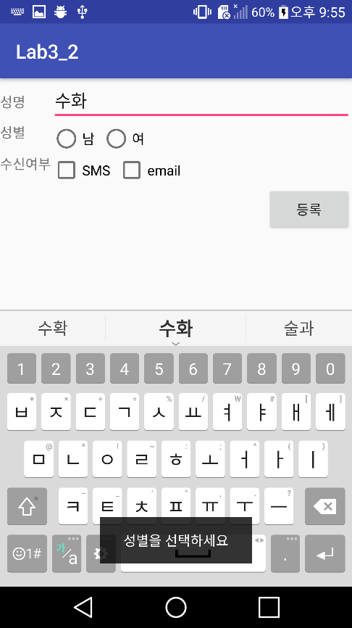

Empty name / sex pressed

New Activity screen

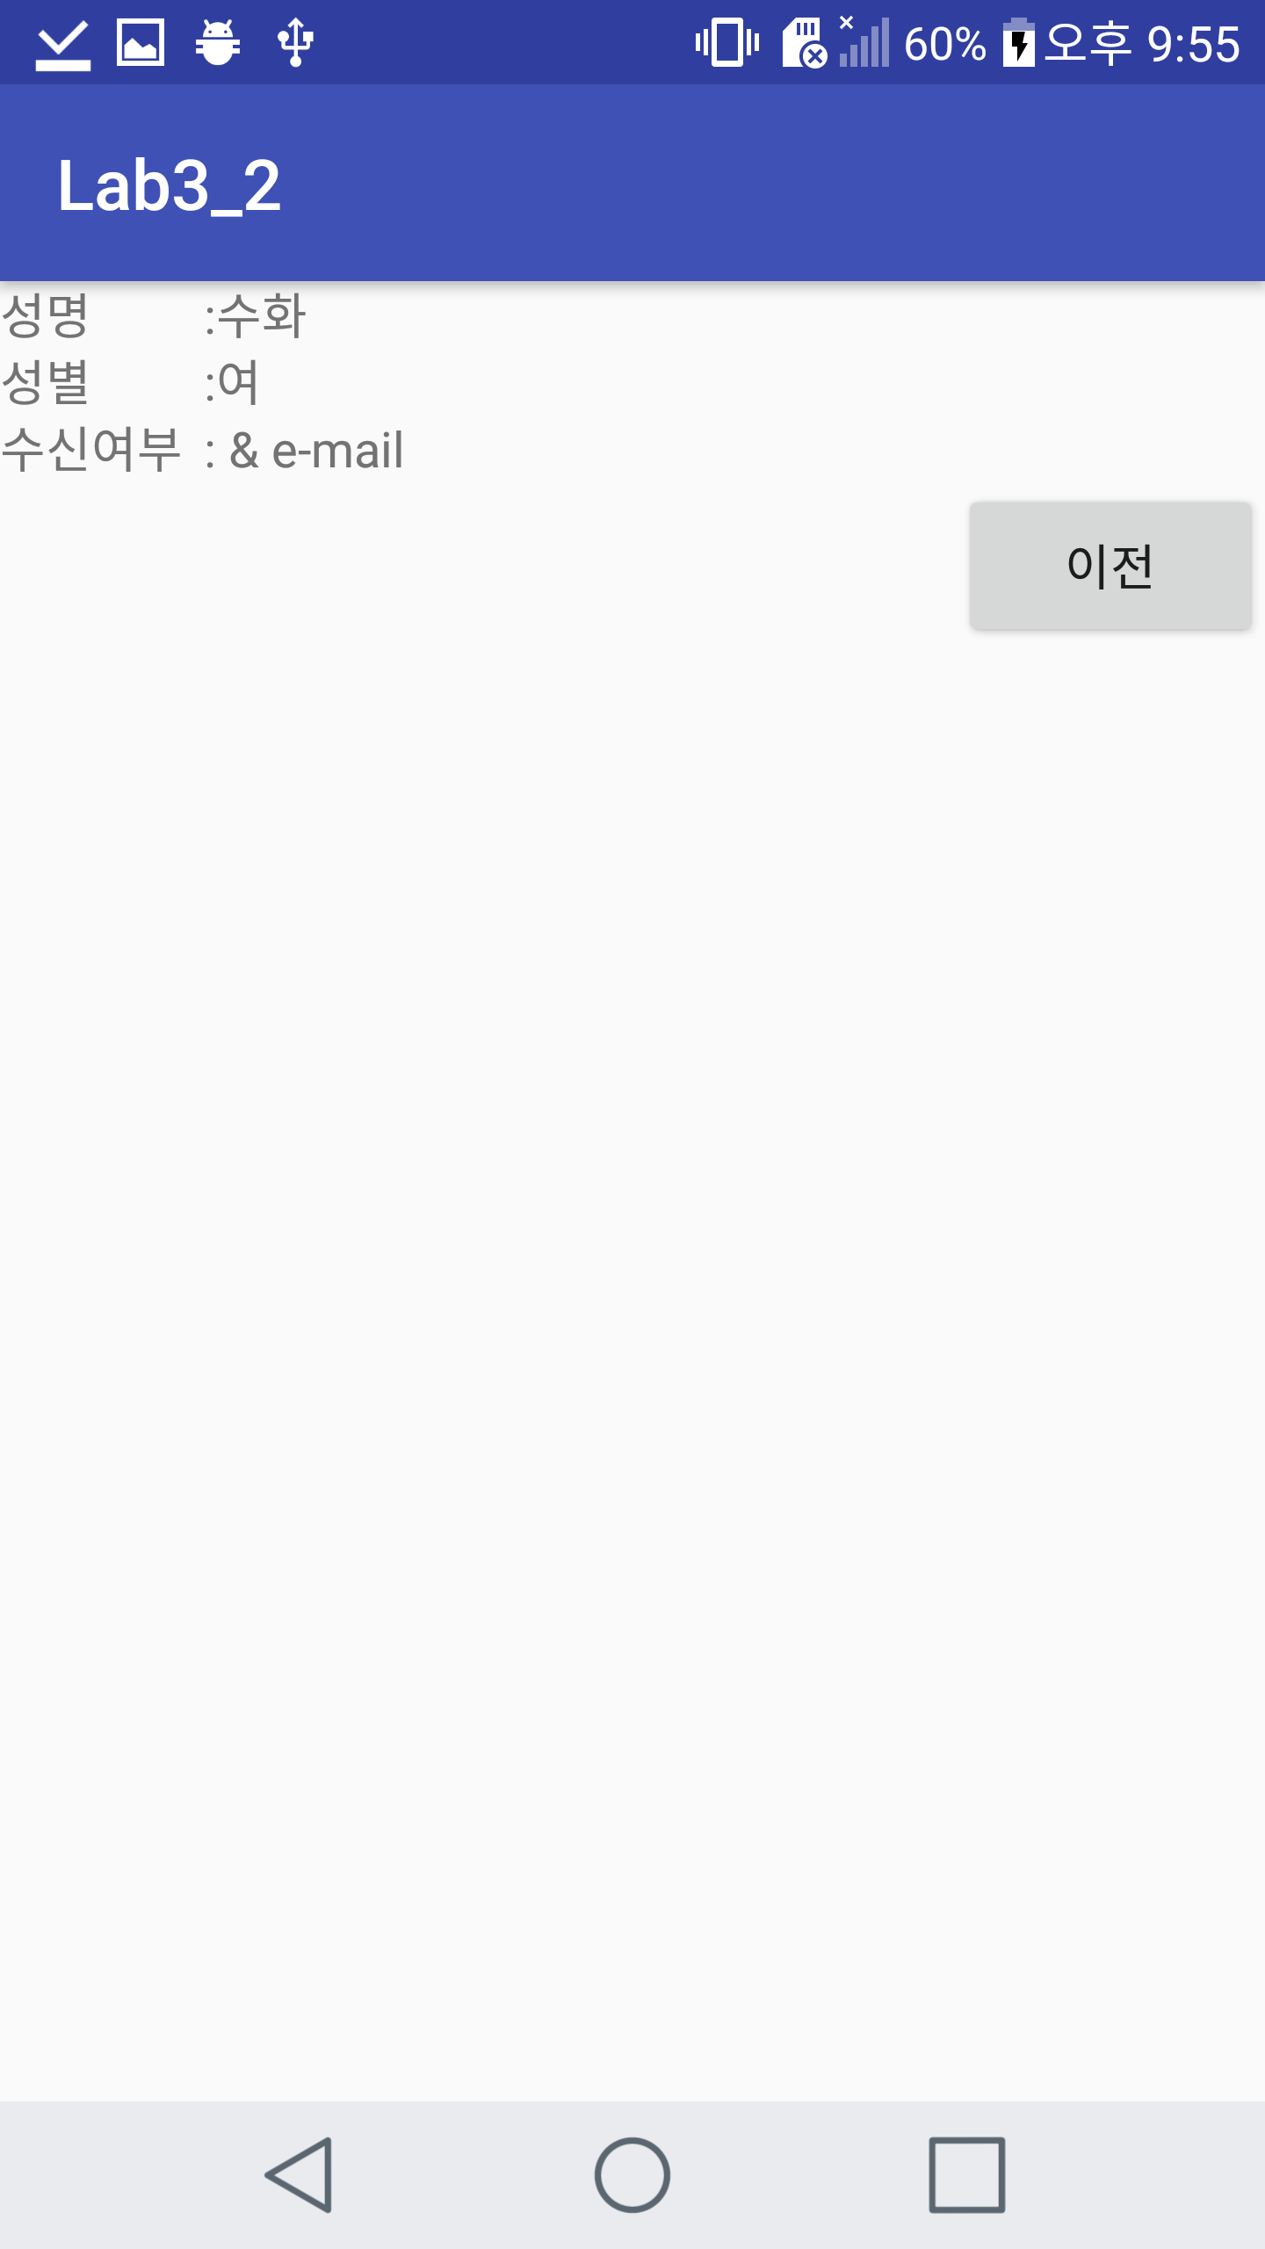

Lab 3.3

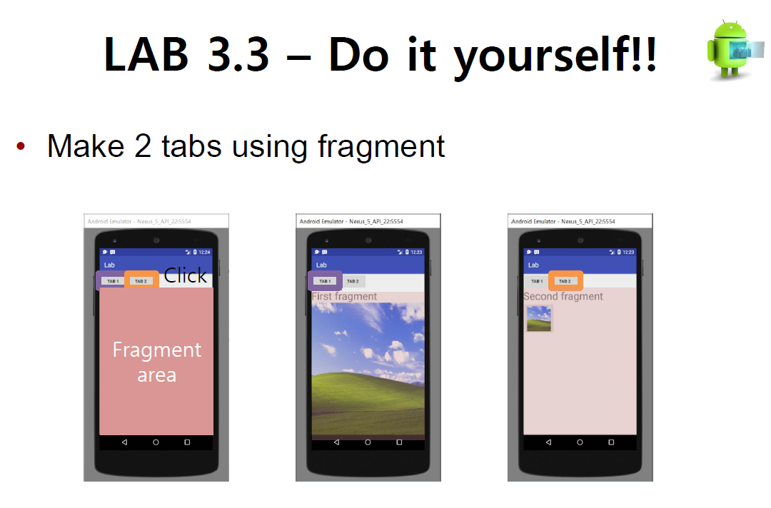

activity_main.xml

<?xml version="1.0" encoding="utf-8"?>  
<LinearLayout xmlns:android="http://schemas.android.com/apk/res/android"  
 android:layout_width="match_parent"  
 android:layout_height="match_parent"  
 android:orientation="vertical">  
  
  
 <!-- When you click "TAB 1" button, First fragment opens. -->  
 <!-- When you click "TAB 2" button, Second fragment opens. -->  
 <LinearLayout  
 android:layout_width="match_parent"  
 android:layout_height="wrap_content">  
  
 <Button  
 android:id="@+id/btnTab1"  
 android:layout_width="wrap_content"  
 android:layout_height="wrap_content"  
 android:text="TAB 1" />  
  
 <Button  
 android:id="@+id/btnTab2"  
 android:layout_width="wrap_content"  
 android:layout_height="wrap_content"  
 android:text="TAB 2" />  
  
 </LinearLayout>  
  
 <!-- FrameLayout that contains Fragment to show image. -->  
 <FrameLayout  
 android:id="@+id/framelayout_for_fragment"  
 android:layout_width="match_parent"  
 android:layout_height="match_parent">  
  
 </FrameLayout>  
  
</LinearLayout>

MainAcitivy.java

package example.com.lab3_3;  
  
import android.support.v7.app.AppCompatActivity;  
import android.os.Bundle;  
import android.view.View;  
import android.widget.Button;  
  
public class MainActivity extends AppCompatActivity {  
  
 public Button btn_frag1;  
 public Button btn_frag2;  
  
 public FirstFragment firstFragment;  
 public SecondFragment secondFragment;  
  
 //init method.  
 public void init(){  
 btn_frag1 = (Button) findViewById(R.id.*btnTab1*);  
 btn_frag2 = (Button) findViewById(R.id.*btnTab2*);  
  
 firstFragment = new FirstFragment();  
 secondFragment = new SecondFragment();  
 }  
  
 //Button click Listener  
 //When you click the buttons, a new activity(page) opens.  
 //TAB1 button - fitXY / Tab2 button - original  
 private void setListener(){  
 btn_frag1.setOnClickListener(new View.OnClickListener(){  
 @Override  
 public void onClick(View view) {  
 getSupportFragmentManager().beginTransaction().replace(R.id.*framelayout_for_fragment*, firstFragment).commit();  
 }  
 });  
 btn_frag2.setOnClickListener(new View.OnClickListener(){  
 @Override  
 public void onClick(View view) {  
 getSupportFragmentManager().beginTransaction().replace(R.id.*framelayout_for_fragment*, secondFragment).commit();  
 }  
 });  
 }  
 @Override  
 protected void onCreate(Bundle savedInstanceState) {  
 super.onCreate(savedInstanceState);  
 setContentView(R.layout.*activity_main*);  
  
 init();  
 setListener();  
 }  
  
  
}

fragment_first.xml

<?xml version="1.0" encoding="utf-8"?>  
<LinearLayout xmlns:android="http://schemas.android.com/apk/res/android"  
 android:layout_width="match_parent"  
 android:layout_height="match_parent"  
 android:orientation="vertical">  
  
 <!-- Use textView to print the first fragment.-->  
 <TextView  
 android:layout_width="wrap_content"  
 android:layout_height="wrap_content"  
 android:text="First fragment"  
 android:textSize="30sp" />  
  
 <!-- fitXY ScaleType displays image that fits on ImageView -->  
 <ImageView  
 android:layout_width="match_parent"  
 android:layout_height="match_parent"  
 android:scaleType="fitXY"  
 android:src="@drawable/img1" />  
  
</LinearLayout>

FirstFragment.java

package example.com.lab3_3;  
  
import android.os.Bundle;  
import android.support.annotation.Nullable;  
import android.support.v4.app.Fragment;  
import android.view.LayoutInflater;  
import android.view.View;  
import android.view.ViewGroup;  
  
public class FirstFragment extends Fragment {  
 @Nullable  
 @Override  
 public View onCreateView(LayoutInflater inflater, @Nullable ViewGroup container, @Nullable Bundle savedInstanceState) {  
 ViewGroup mView = (ViewGroup) inflater.inflate(R.layout.*fragment_first*, container, false);  
 return mView;  
 }  
}

fragment_second.xml

<?xml version="1.0" encoding="utf-8"?>  
<LinearLayout xmlns:android="http://schemas.android.com/apk/res/android"  
 android:layout_width="match_parent"  
 android:layout_height="match_parent"  
 android:orientation="vertical">  
  
 <!-- Use textView to print the second fragment.-->  
 <TextView  
 android:layout_width="wrap_content"  
 android:layout_height="wrap_content"  
 android:text="Second fragment"  
 android:textSize="30sp" />  
  
 <!-- Matrix ScaleType displays Original Image. -->  
 <ImageView  
 android:layout_width="match_parent"  
 android:layout_height="match_parent"  
 android:scaleType="matrix"  
 android:src="@drawable/img1" />  
  
</LinearLayout>

SecondFraggment.java

package example.com.lab3_3;  
  
import android.os.Bundle;  
import android.support.annotation.Nullable;  
import android.support.v4.app.Fragment;  
import android.view.LayoutInflater;  
import android.view.View;  
import android.view.ViewGroup;  
  
public class SecondFragment extends Fragment {  
 @Nullable  
 @Override  
 public View onCreateView(LayoutInflater inflater, @Nullable ViewGroup container, @Nullable Bundle savedInstanceState) {  
 ViewGroup mView = (ViewGroup) inflater.inflate(R.layout.*fragment_second*, container, false);  
 return mView;  
 }  
}

Screen-shot

Initial screen

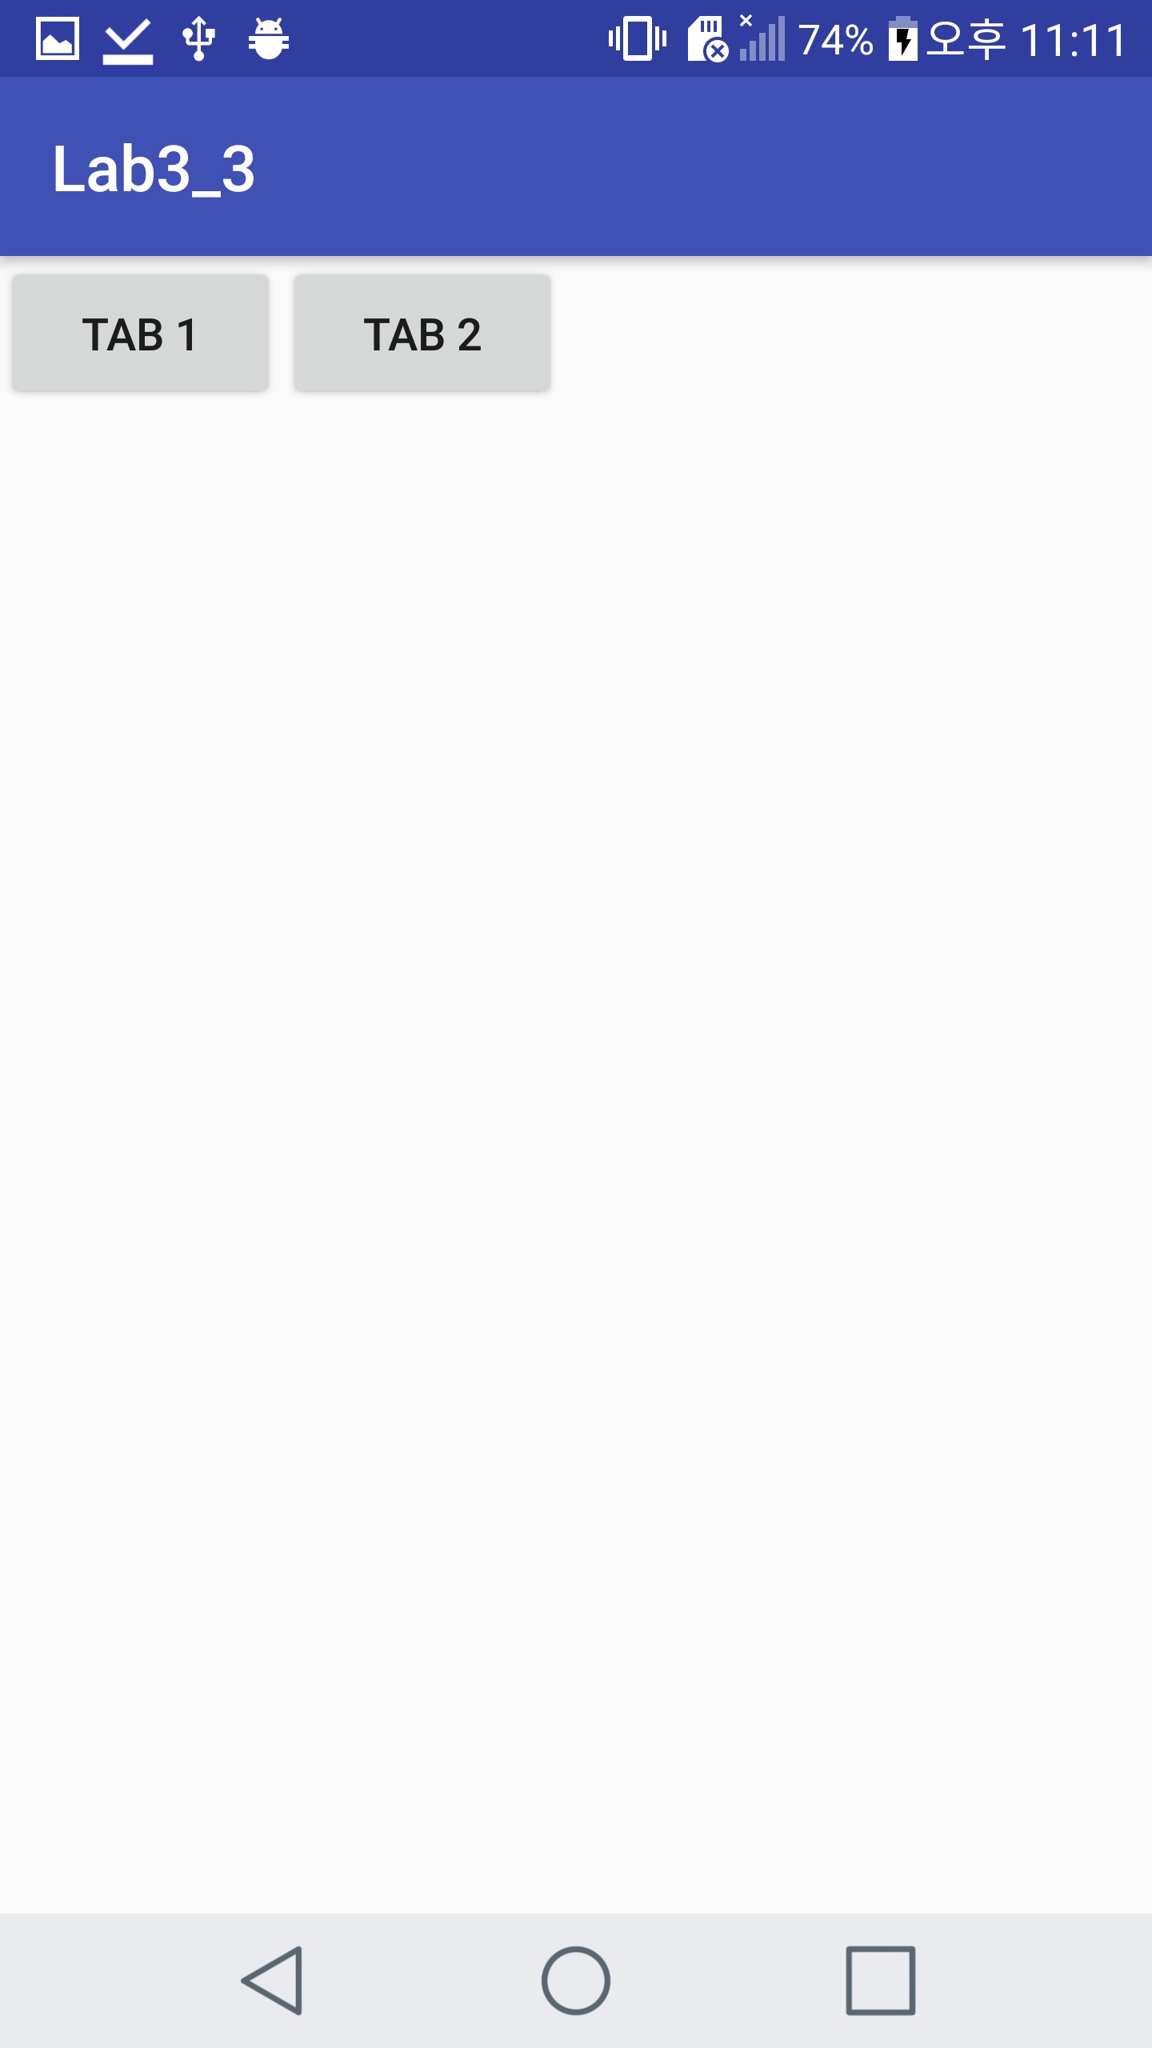

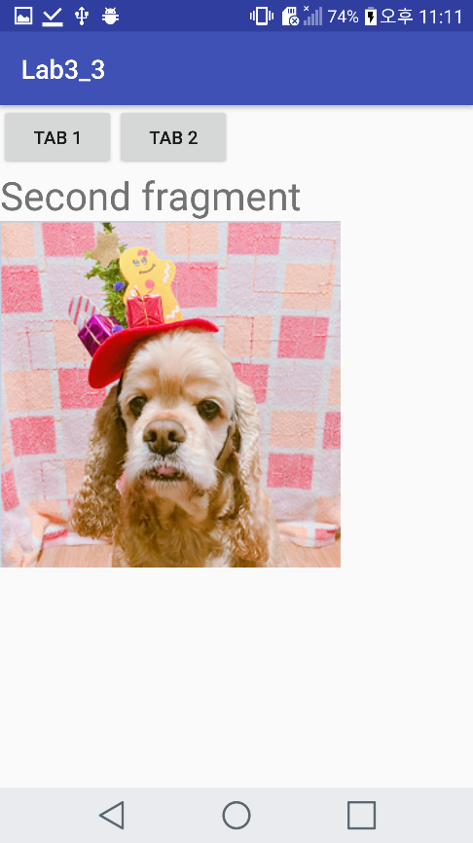

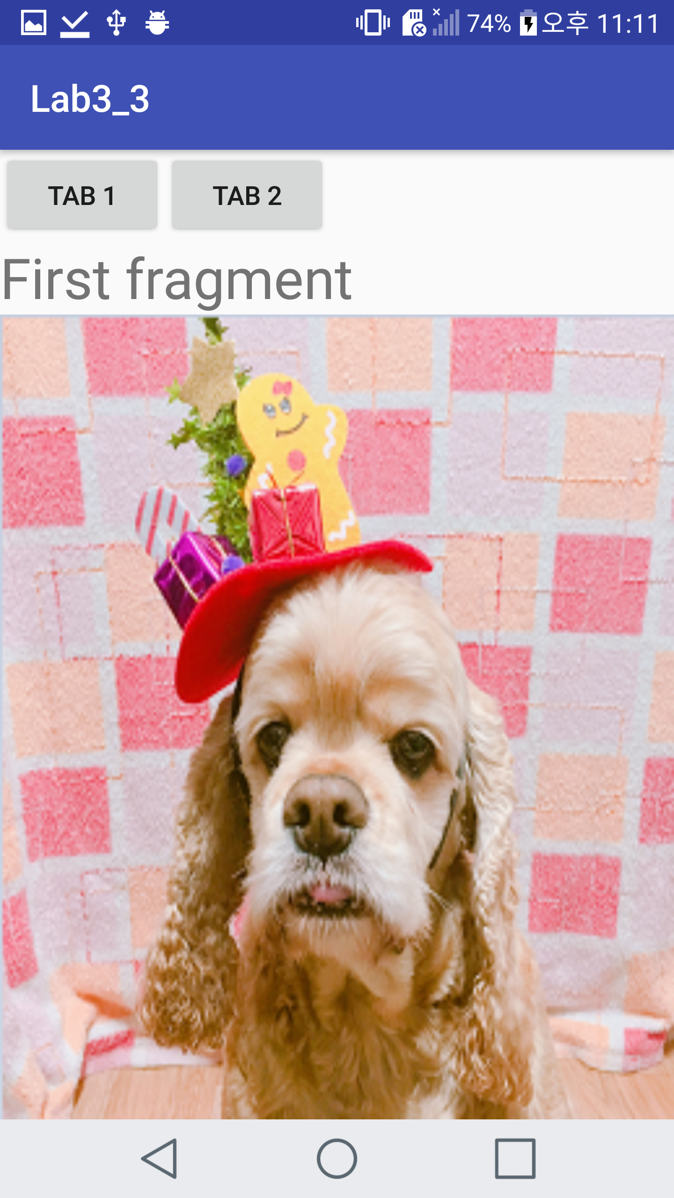

Push TAB1 button Push TAB2 button

 Image source

**<Github address>**

**https://github.com/YooSuhwa/Mobile-Programming.git**